React Applications - Creating and Running

- How to create react application ?
Step 1. In D drive create a folder and name it my_react_projects
Step 2. Open cmd prompt
Step 3. cd D:\ my_react_projects
Step 4. npx create-react-app react-app1
Step 5. WAIT FOR FOLLOWING GETS PRINTED AS IN THE IMAGE BELOW
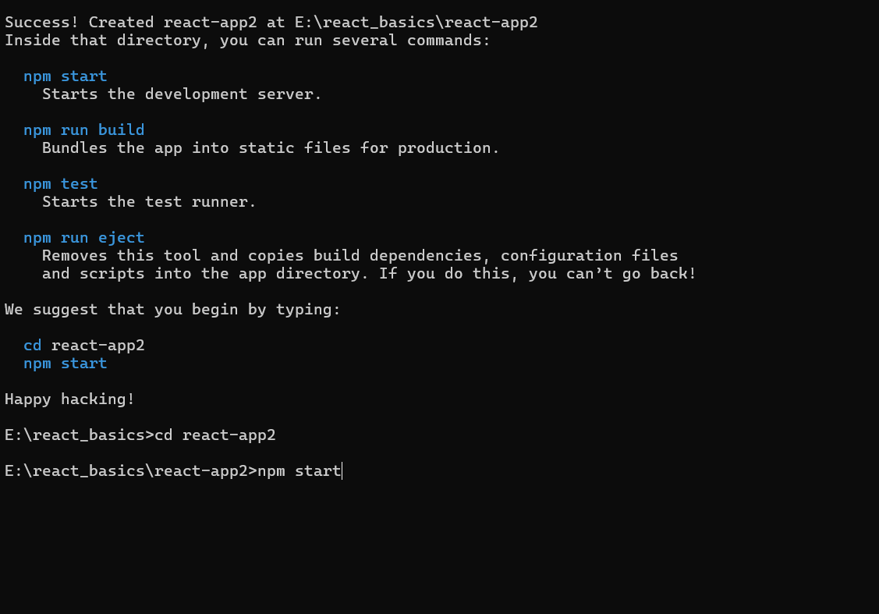
Step 6. npm start
Look at the output that is like as in the below image
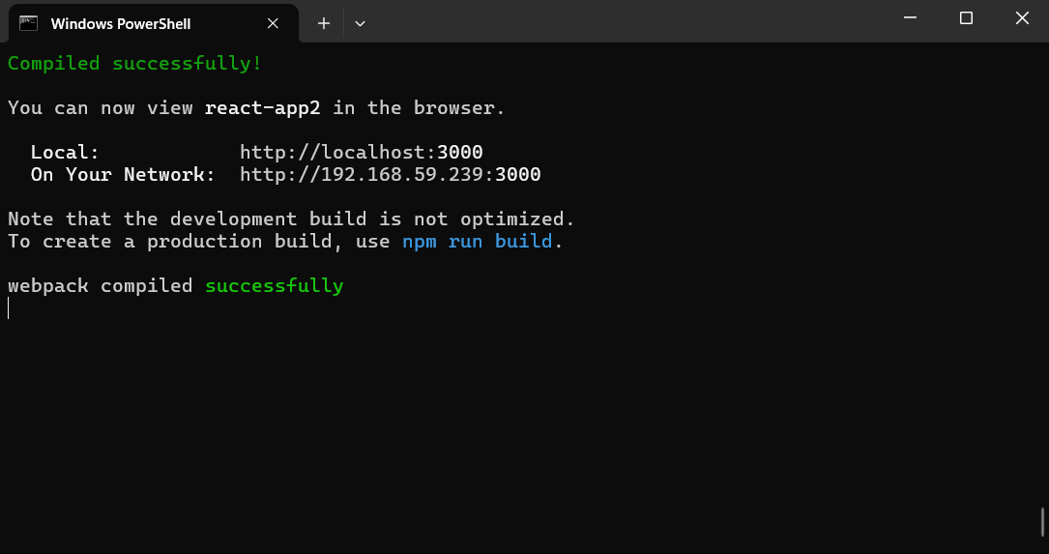
See in the server the output of the react application.
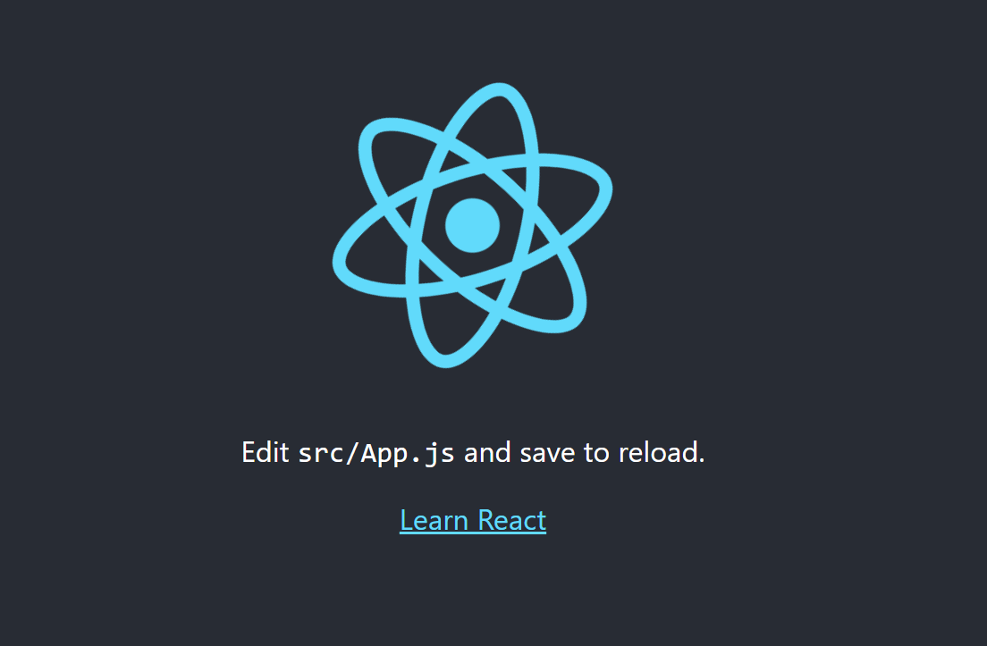

Step 6. Open folder react-app1 in VSCode
Step 7. Open file App.js and delete all the content and type the following lines
Step 8. App.js
import React from 'react';
import ReactDOM from 'react-dom';
const Demo=()=>{return <h1>Welcome to React Training at NIET, Greater Noida</h1>};

export default Demo;
Step 9. Now open index.js file and delete all the content and type the following lines
// index.js
import React from "react";
import ReactDOM from "react-dom";
import Demo from "./App";

const root = ReactDOM.createRoot(
document.getElementById("root")
);
root.render(
<React.StrictMode>
<Demo />
</React.StrictMode>
);

Step to run the application: Open the cmd / terminal and type the following command.
npm start
Output: Open the browser and our project output is shown in the URL http://localhost:3000/

